EEG ELECTRODES

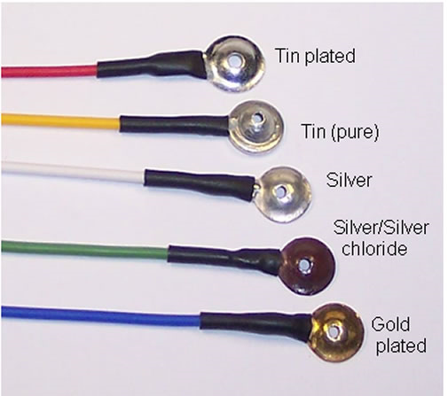

Modeling the Electrodes Clinical Electrode Placement:

- There are several ways electrodes may be placed in an EEG acquisition
- The most common method is the 10-20 system, requiring manual placement of 19-32 electrodes based on anatomical landmarks and relative distances
- Better methods include dense electrode nets with standard locations, electrodes with MR-visible markers, and electrode locations recorded with a 3D tracker
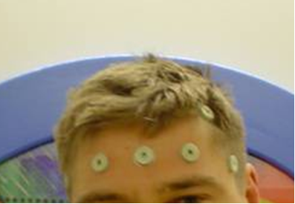
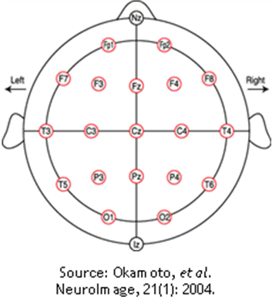
Aligning Electrodes to Our Head Models :

- In order to use Neuroses, we need to give it the location of each electrode in the reference frame of the head model
- To do this, we first build a very simple model of the patient head surface in Slicer
- If the 10-20 system or electrode markers were used, we then place fiducially in Slicer at each electrode location, transform the coordinates from Slicer coordinates to Neuroses coordinates, and output the electrode file
- If a tracker or standard net locations were used, we place fiducially at the four reference points on the Slicer model, and from these four points we find the matrix to transform the given acquisition coordinates to the Slicer reference frame. We use this matrix to transform all electrode coordinates. We then transform the electrodes from Slicer into Neuroses and output the electrode file.
- 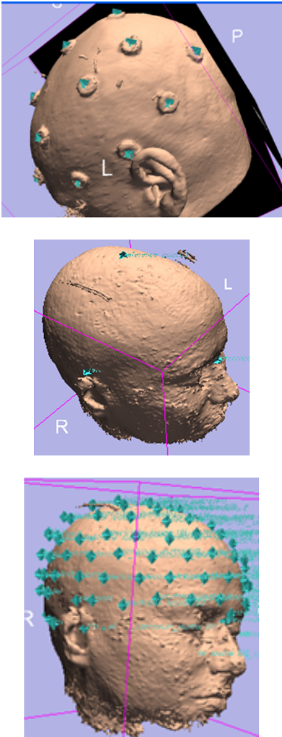
Flexible Framework for Source Localization :

- In order to solve the EEG inverse problem, one must optimize the dipole configuration through repeated forward simulations
- We have implemented and tested several optimization techniques:
- Exhaustive search over the entire brain or a specified ROI (good for clinical source localization)
- Simultaneous Perturbation Stochastic Approximation (SPSA) for very efficient stochastic optimization (good for research when many localizations must be carried out quickly)
- NeuroFEM’s built-in Simplex optimization (useful only if no prior map is to be used)
- Other inverse methods may very easily be implemented in this framework, and the framework may be used to compare different methods in a research setting
Prior Information
Defining Prior Probabilities for Focal-Point Locations:

- There are many methods in the literature for locating focal-point hot-spots and assigning prior probabilities on dipole locations
- Any such method may be used to define a prior probability map for use within our framework
- Automatic methods of assigning prior probabilities may look at factors such as:
  - Anatomical considerations for where focal points are likely to lie
  - Machine-vision techniques for locating specific anomalies such as cysts or lesions
  - Asymmetry measures between the two hemispheres, measures of GM/WM blurring, volumetric measures of various structures, measures of cortical thickening, etc.
- Our framework is very useful in testing and comparing different prior formulations

The psychologists wish to measure patients’ anxiety. The measurement is shown to patients so they can see their anxiety before they feel it. This enables patients to learn how to monitor and control anxiety when it is still in the early stages. Thus, anxious patients can learn to manage their anxiety before it becomes a problem.

- Study brain activity associated with rumination and anxiety.
- Alpha brain waves are a good measure of anxiety.
- The subject responds to audio and visual cues.
- We take psycho-physiological readings such as ECG and EEG while the subject performs the task.
- We synchronise the experimental events to the data, so we know when and which thought processes occur.
- Readings are manipulated to generate data for statistical analysis

- Measurements
    - Electroencephalograph (EEG) for Alpha-wave brain activity
    - Electrocardiogram (ECG) for stress level
    - Skin Conductance Response (SCR) arousal level
- Health & Safety
    - The tester or the participant should not be at risk at any time
    - Good hygiene, avoid cross contamination
    - Electrical protection eg. isolation
- Participants
    - Gather participants that meet the required criteria

- Choose equipment which will make the task as easy as possible.
- EEG is obtained using a Bio Semi 128 channel Active Electrode system, recorded with ActiView program.
- ECG and SCR recorded using Cambridge Electronic Design (CED) equipment and Spike program.
- Data analysis handled by BESA program.
- Timing and control is handled by E-Prime program.
- Electrical Safety and Shock Prevention for medical research
    - Extra Low Voltage (battery) for the EEG System
    - Bio Semi Active Electrodes have built in current limit system with auto shutoff
    - Remaining electrodes have electrical isolation from their amplifiers
    - Amplifiers are powered by Isolated Power Supply Units
    - Cross Contamination
    - Traditionally, electrodes required skin to be scratched to create better electrical contact. This can lead to cross infection
    - The Bio Semi Active Electrodes require no skin preparation, making things safer and quicker
    - Separate washing area was needed to ensure electrodes were kept away from food preparation areas
    - Disposable electrode pads were used for the remaining signals

- The experiment is controlled by the PC running E-Prime.
- E-Prime presents a series of visual and audible cues to the participant.
- In synchrony to these cues, triggers are sent to BioSemi (EEG) and CED (ECG and SCR).
- Triggers are sent out of the printer port using its 8 data channels.
- These may appear as binary, levels, or as a number.
- Trigger information contains Record/Pause command and task identification
- In this way the data indicates exactly where tasks begins and end

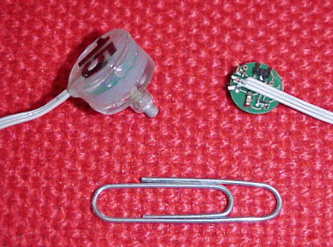

- Record EEG with ActiView.
- Simple and straightforward to use.
- Data is sent to the PC via a fibre optic cable (electrically isolated).
- Settings can be stored in a configuration file (.cfg) and loaded each time ActiView is run.
- Other uses of the configuration file include:
- Enables the remote record function ‘pause save’.
- Stores the file location where data file will be stored.
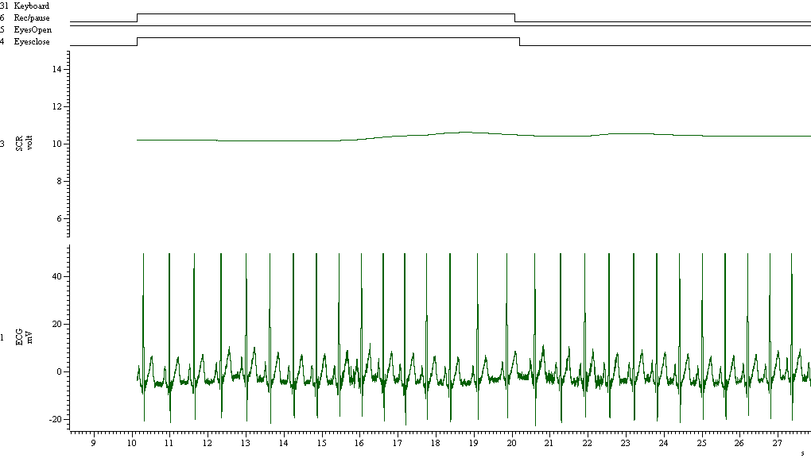

  - Stayed safe electrically and medically
  - Gathered approximately 100 participants
  - Used two rooms
  - Recorded EEG on PC1 with BioSemi Active Electrode equipment
  - Analysed EEG on PC1 with BESA
  - Recorded & analysed ECG and SCR data on PC 2 with CED hardware and Spike
  - Controlled the experiment on PC 3 with E-Prime and connected it to the other two PCs
  - Connect systems between both rooms using 5 monitors, 4 keyboards and mice etc.
  - Benefits of using BioSemi Active Electrodes:
    - Low noise levels due to first amplifier stage being in the electrode
    - Saves approx 30 minutes as there is no need to prepare the skin surface
    - Almost no risk of infection
  - Experiment documented for future reference

